In fact, when developing a new software, the software development team must describe the software requirements in software requirements specification before they do the design and coding. They describe the software requirements by using text, formulas, drawing models and table description. The software tools department at FPT University want to develop a new software tool named EduNext website to allow students to learn many courses in the constructivism way. Following the constructivism way, the students will build up their knowledge more actively by searching content on the internet, reading text books, interacting with other students in the same group or in the same class. The EduNext website need to have many functions which allow importing data about student list from FAP system, displaying the list of students, updating the list of students, adding questions, updating questions, listing questions, creating student groups in the same class by teacher, answering the questions by students, voting answers by students, voting answers by teacher, signing in EduNext by using @fpt.edu.vn email accounts of students or teachers. Besides, EduNext can record data of the interaction processes between students when students at FPT University post the answers of the questions, reply or comment the answers of other students, vote the answers of other students or even chat with other students. Use case approach is one of the most effective ways to describe the software requirements.

**All the answers must be in English and reflect this exam paper. If your answers of the questions in this exam paper have any keywords not related to this exam paper, the answers of the questions will get ZERO.**

**Question 1:** Complete all parts of the first page of the software requirements specification. (1 point)

Software Requirements Specification

for

<Project>[Student must replace this line by the name of project in the exam paper] (0.25 point)

Version 1.0 approved

Prepared by <Mai Tran Huy_ He1600000>[Student must replace <author> by your full name and studentID] (0.25 point)

<Fpt univer hoa lac>[Student must replace this line by the name of the FU Campus you take the exam] (0.25 point)

<date created> [Student must replace this line by the date you take the exam] (0.25 point)

**Question 2:**

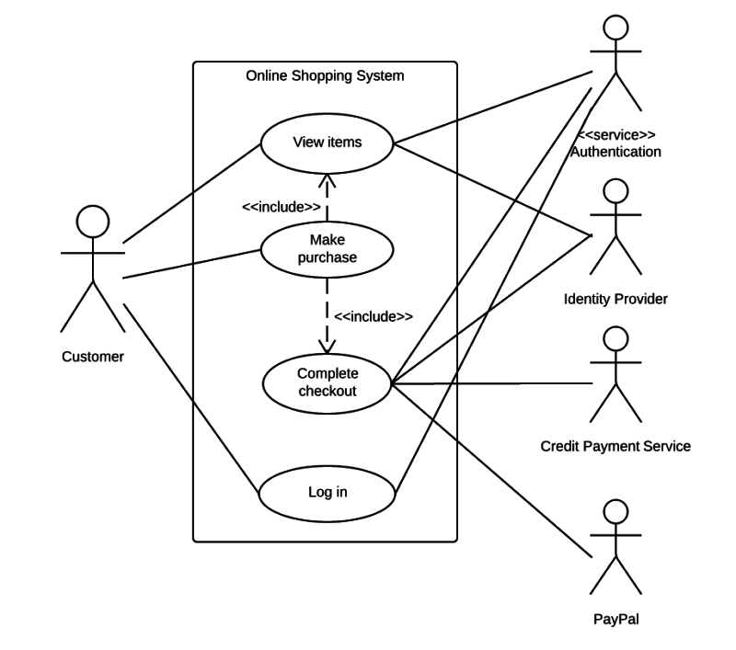

Use case diagram is an effective way to visualize the interaction between actors and the software system. One Use case diagram need one rectangle which represents one system or one software application. One oval represents one use case. The name of the use case must begin with the verb and follow by an object.

1. In this exam paper, the name of the rectangle is: ………( 0.1 point): EduNext website
2. The actor may be human, other software systems or devices. In this exam paper, list the name of >= 3 actors is: ……..(0.6 point): Student, Teacher, FAP
3. In this exam paper, list the name of >= 5 use cases are: …….(1 point): learn many courses (Learn Courses), displaying the list of students (Display students list ), updating the list of students, adding questions, updating questions, listing questions, creating student groups, answering the questions by students, voting answers by students, voting answers by teacher, signing in EduNext
4. The actors are inside or outside of the rectangle? ……… (0.1 point): Outside
5. The ovals represent the use cases are inside or outside of the rectangle? ………(0.1 point): Inside
6. The primary actor of the use case **add new question** is: …….(0.2 point): Teacher
7. The secondary actor of the use case **add new question** is:….. (0.2 point): Student
8. Based on the fact you already used EduNext website. The use cases in this exam paper may have relationship.
9. 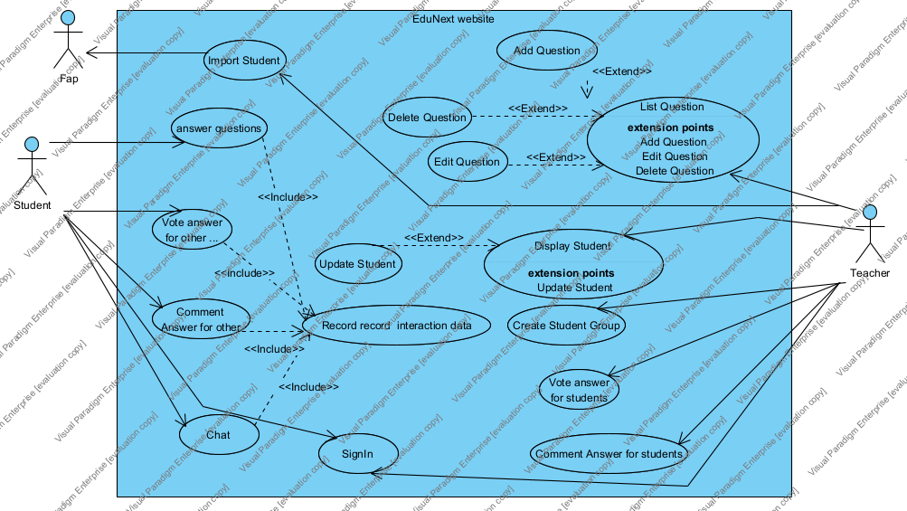

8.a List the name of two use cases that have **extend** relationship: …….(0.3 point): listing questions, Edit question

8.b The name of **base use case (in 8.a)** is: …..(0.2 point): ): listing questions

8.c The name of **~~included~~ use case (in 8.a)** is: ……(0.2 point): Edit question

8.d The dashed line with an arrow that points to which use case? …..(student write the name of use case) (0.1 point) : listing questions

1. Based on the fact you already used EduNext website, the use cases in this exam paper may have relationship.

9.a List the name of two use cases that have **include** relationship: …….(0.3 point): Chat, Record Interation data

9.b The name of **based use case (in 9.a)** is: …..(0.2 point): Chat

9.c The name of **~~extend~~ use case** **(in 9s.a)** is: ……(0.2 point): Record Interation data

9.d The dashed line with an arrow that points to which use case? …… (student write the name of use case) (0.2 point): Record Interation data

**Question 3:** Writing detail one use case, the use case **adds (+) new question** in the following format. (4 points)

1. UC ID and Name: UC-1 and Add Question (0.1 point) the UC – 1 and the use case name here.
2. Created By: [huectm@fe.edu.vn](mailto:huectm@fe.edu.vn) (0.1 point) The name of your email account.
3. Date Created: 17-3-2023 (0.1 point) The date you take the exam.
4. Primary Actor: Teacher (0.2 point) the name of the actor that initiate use this use case.
5. Secondary Actors: Student (0.2 point) The name of actor that use the data of the primary actor.
6. Trigger: The Teacher select Add Quest (0.3 point) the events that occur and then this use case will run.
7. Description: (0.1 point)

Add other question into list question

1. Preconditions: (0.3 point) The preconditions that must be true or must be done before this use case can run. 8.1 …., 8.2 …., 8.3 ….. may be more or less, depending on your ability to define. Don’t need to write all 8.1 …., 8.2 …., 8.3 ….. items.

8.1 Teacher must signin

8.2 The Course n must exits…..

8.3

1. Postconditions: (0.3 point) Describe the things must be done after the actors interact with this use case. 9.1 …., 9.2 …., 9.3 ….. may be more or less, depend on your ability to define. Not always need to writing all 9.1 …., 9.2 …., 9.3 ….. items.

9.1 The New question must save to DataBase

9.2

9.3

1. Normal Flow: 0.7 point) Describe the sequence of steps in normal case that must be performed by the actors or the system responses. 10.1 …., 10.2 …., 10.3 …..10.4 … 10.5 … may be more or less, depend on your ability to define. Not always need to writing all 10.1 …., 10.2 …., 10.3 …..10.4 … 10.5 … items.

10. 1 The teacher select add new Question

10. 2 The System show Add new question Form

10. 3 The Teacher Enter new Question contents (A1.0)

10. 4 The Teacher submit the new Question

10. 5 The System validates new Question contents (E1.0)

10.6 The system save the new question to the database

1. Alternative Flows: A1.0 (0.7 point) Describe the sequence of steps in different case that can be performed by the actors or the system responses. 11.1 …., 11.2 …., 11.3 …..11.4 … 11.5 … may be more or less, depending on your ability to define. Not always need to writing all 11.1 …., 11.2 …., 11.3 …..11.4 … 11.5 … items.

11. 1 The Teacher sets question attributes

11. 2 The teacher returns the step 10.4

11. 3 …..

11. 4 …..

11. 5 …..

1. Exceptions: **E1.0** (0.3 point) Describe the sequence of steps that can be handled or implemented when there are any exceptions.

12. 1 The system highlights the error information field

12. 2 …..

12. 3 …..

1. Priority: (0.1 point) Priority level will help better plan when implement.
2. Frequency of Use: (0.1 point) The more frequency of use, the more important
3. Business Rules: (0.2 point) All things in software related to data. The business rules should be specific for design and coding.
4. Other Information: (0.1 point) may describe the quality here for more info.
5. Assumptions: (0.1 point) The assumptions about the data related to this use case.

**Question 4:** writing 2 non-functional requirements.

1. The term of the most important non-functional requirements and at least 2 statements. Should be specific in number, explain the number so that the tester can test the software and make conclusion the test is passed or failed. (0.5 point)
2. The term of the second important non-functional requirement and at least 2 statements. Should be specific in number, explain the number so that the tester can test the software and make conclusion the test is passed or failed. (0.5 point)

